**SIMPLILEARN PHASE-2 PROJECT**

**FLY AWAY**

**Core concepts used in the project:**

* Used Java Language in Eclipse IDE.
* File Handling
* Collections framework
* Sorting
* Flow Control
* Recursion
* Exception Handling
* Streams API
* MYSQL-workbench

**Flow Chart**

Travel details page

Home

Admin login page

Fetching Flight details from Database

Add flight popup

Password change popup

Admin Dashboard Page

Fetching Flight details as per request

Checkout page

Traveler details

Available Flight Details

Confirmation page

The project is planned to be completed in 3 sprints. Tasks assumed to be completed in the sprint are:

* Creating the flow of the application
* Initializing git repository to track changes as development progresses.
* Writing the Java program to fulfill the requirements of the project.
* Testing the Java program with different kinds of User input
* Pushing code to GitHub.

**Sprint 1**

* As a developer, I want to build register/login functionality.
* As a developer, I want to allow user to view flights as per preference.
* As a developer, I want to allow admin to add/modify flight related information

**Sprint 2**

* As a developer, I want the user to be able to successfully view flight prices and names as per preference
* As a developer, I want the user to be able to book a flight via a payment gateway
* As a developer, I want the payment gateway to be authenticated properly to prevent any flaws in the transaction process

**Sprint 3**

* As a user, I want to book a flight securely, with proper amount deductions from my account, post the booking process

**PROJECT GITHUB REPOSITORY**

Link: https://github.com/VijayMoirangthem/FlyAway.git

**Screen shots**



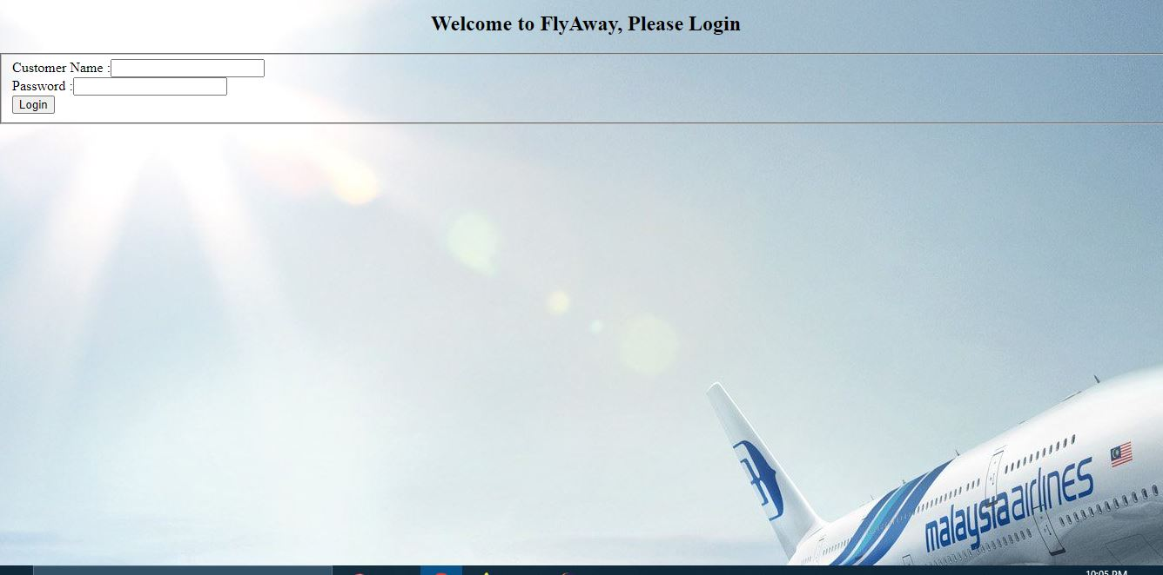

## Add Flights

## Payment

## Logout message

## Pushing the code to GitHub repository

* Open your command prompt and navigate to the folder where you have created your files.

*cd <folder path>*

* Initialize repository using the following command:

*git init*

* Add all the files to your git repository using the following command:

*git add .*

* Commit the changes using the following command:

*git commit . -m <commit message>*

* Push the files to the folder you initially created using the following command:

*git push -u origin master*

## **Conclusions**

In the program an application has been developed with a duration of three sprints. This application handle the data of the FlyAway. All the data about airlines are visible to user. The admin can login through a User ID and password and manipulated the data.